Verify Check  Cab  Cleanliness  Seat condition OK  Operator restraint provided  Instruments operational & labeled  Levers / controls operational  Pedals in good condition  ROPS to AS 2294  Windows / wipers / washers  Rear view mirrors  Operator instruction  (available on plant)  Verify Check  Warning devices  Horn  Amber flashing beacon (all)  Reversing alarm  Verify Check  Warning signs (in cabin)  SEAT BELTS MUST BE WORN  Verify Check | Supplier verification & Plant details
 | Plant owner:
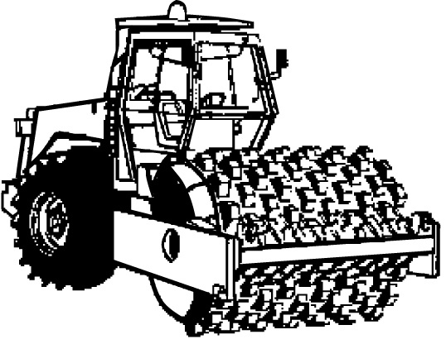 | Address:
 | City/Suburb:
DANGER – SAFE WORKING LIMITS ON BATTERS  Ratio 4 to 1  example only. As per manufacturer’s specification | Phone:
 | Plant make:
Verify Check  Exhaust | Plant model:
L N H  Verify Check  Locating lock for  Low/Neutral/Lower range  padlock provided  Warning sign – hasp must be  locked in position before  operating | Serial no.:
Verify Check  Engine guarding | Signature:
 | Date:
Verify Check  Tyres  Wheels  Brakes  Park brake | Statement of operator competence required
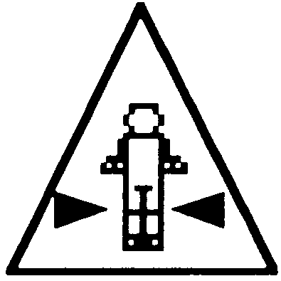  Verify Check  Crush point hazard  sign displayed both sides  Verify Check  Rubber mounts (drum)  Verify Check  Drum cleaning rakes |  Plant to conform to manufacturer’s specifications and Plant Regulations.   Plant operator is to provide daily checksheets to WDA on a weekly basis   Where applicable, Personal Protective Equipment must be worn.   Plant Log Book detailing service history in accordance with Manufacturer’s specifications should be written legibly in English.   Contractor must produce proof of competence of operator, e.g., Certificate of Competence, Licence, detailed Log Book
Verify Check  Handrails  Steps | WDA use only
Hydraulics  Verify Check  Rams  Hoses  Connections  (check for excessive  wear, leaks and creep) | Note: Sign only when all items have been checked
 | Plant check by:
Instructions:  Verify Box to be ticked by Owner / Supplier / Operator prior to arrival onsite.  Check Box to be ticked after visual inspection by WDA | Position:
 | Date: |  | / /

